

East Delta University

Lab Report
CSE 328 Spring 2025
Section – 1

Junaid Hossain
222008812

Task – 1:
Modify the BFS algorithm implementation to skip nodes marked as obstacles [for any
tree you want]

Introduction:
Breadth-First Search (BFS) is an algorithm that explores a graph level by level, finding the shortest path. The following code adapts BFS to navigate a grid with obstacles, demonstrating how to find the shortest valid path while avoiding restricted cells.

Solution Code:

from collections import deque

def bfs_with_obstacles(graph, start, obstacle):
queue = deque([start])
visited = set()
traversal_order = []

while queue:
current = queue.popleft()

if current not in visited and current not in obstacle:
visited.add(current)
traversal_order.append(current)

for i in graph[current]:
if i not in visited and i not in obstacle:
queue.append(i)

return traversal_order

# Example usage:
graph = {
'0': ['1', '9'],
'1': ['6', '3'],
'2': [],
'3': ['4','2'],
'4': [],
'6': ['8'],
'9': ['6','13'],
'8': [],
'13': [],
}

obstacle = ['6']
start = '0'

print("Traversal Order Skipping Obstacles:", bfs_with_obstacles(graph, start, obstacle))

Output:

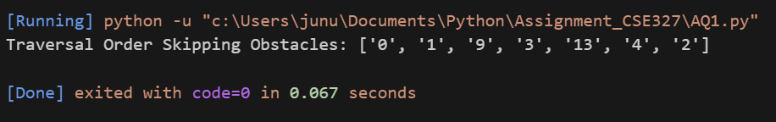

Conclusion:
The give exercise shows us to find the shortest path even with restrictions, which reflects the real world. Thus completing our objective.
Task – 2:

Modify the DFS algorithm implementation to check if a graph is connected and count
connected components [for any tree you want]

Introduction:
The DFS algorithm explores graph branches deeply for each node path. This task is for DFS to check if all nodes in a graph are reachable from a starting point, thus determining if the graph is connected.

Solution Code:

def dfs(graph, start):
stack = [start]
visited = set()
traversal_order = []

while stack:
current = stack.pop()

if current not in visited:
visited.add(current)
traversal_order.append(current)

for i in reversed(graph[current]):
if i not in visited:
stack.append(i)

if len(visited) != len(graph):
print("The graph is not connected.")
print(f"Total nodes visited {len(visited)}, total nodes in graph {len(graph)}")
else:
print("The graph is connected.")
print(f"Total nodes visited {len(visited)}, total nodes in graph {len(graph)}")

return traversal_order

# Example usage:
graph = {
'0': ['1', '9'],
'1': ['6', '3'],
'2': [],
'3': ['4','2'],
'4': [],
'6': ['8'],
'9': ['6','13'],
'8': [],
'13': [],
'5':[]
}

start = '0'
print("DFS Traversal:", dfs(graph, start))

Output:

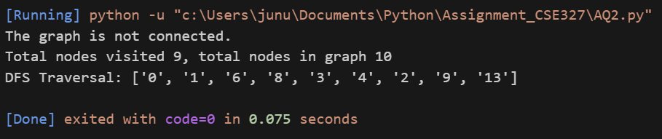
Conclusion:
The given tasks has shown that DFS can check graph connectivity by seeing if all nodes are visited from a single start. Tracking visited nodes is key. A graph is connected if one DFS visit all nodes
Task – 3:

Implement the A* Algorithm in Python and show the optimal path and cost of going from node ‘A’ to node ‘G’ of the following graph

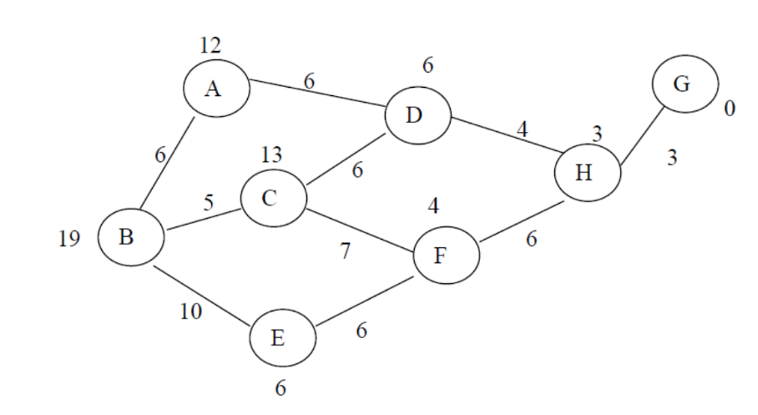
Introduction:
A* search is an informed search algorithm used for pathfinding and graph traversal. It efficiently finds the shortest path between a start and a goal node by combining the actual cost from the start node to the current node and a heuristic estimate of the cost from the current node to the goal node.

Solution Code:

h = {
'A':12,
'B':19,
'C':13,
'D':6,
'E':6,
'F':4,
'G':0,
'H':3,
}

graph = {
'A': {'B': 6, 'D': 6},
'B': {'A': 6, 'C': 5, 'E': 10},
'C': {'B': 5, 'F': 7},
'D': {'A': 6, 'H': 4},
'E': {'B': 10, 'F': 6},
'F': {'C': 7, 'E': 6, 'H': 6},
'G': {'H': 3},
'H': {'D': 4, 'F': 6, 'G': 3},
}

def a_star_search(start, goal):
open_set = {start: h[start]}
came_from = {}
path_cost = {node: float('inf') for node in graph.keys()}
path_cost[start] = 0

while open_set:
current = min(open_set, key=lambda x: open_set[x])

if current == goal:
print("Path cost:", path_cost[current])
return reconstruct_path(came_from, current)

del open_set[current]

for neighbor, dist in graph[current].items():
tentative_path_cost = path_cost[current] + dist
if tentative_path_cost < path_cost[neighbor]:
came_from[neighbor] = current
path_cost[neighbor] = tentative_path_cost
f_score = tentative_path_cost + h[neighbor]
open_set[neighbor] = f_score

return None

def reconstruct_path(came_from, goal):
path = [goal]
while goal in came_from:
goal = came_from[goal]
path.insert(0, goal)
return path

path = a_star_search('A', 'G')
print("Path found by A*:", path)

Output:

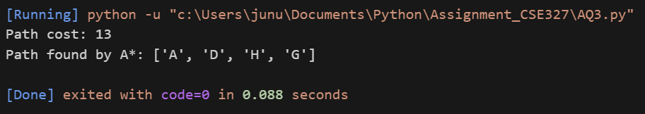
Conclusion:
The given task shows us how to find the shortest path via A* algorithm. The path can be found more effectively if the heuristics values are more precise.

